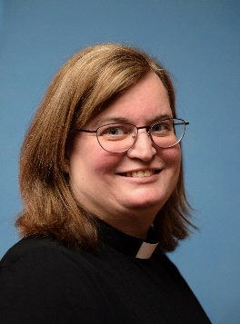
CASTLE METHODIST CHURCH

A letter from Chris Preece …

December 2022

Dear Friends,

There are some books which have a huge amount of wisdom in them. One such book which manages to sum great things up in very few words is Charles Mackesy’s book, ‘The Boy, The Mole, The Fox and the Horse.’ There are enough words and phrases of wisdom in it for many letters and reflections on the character of God. One such phrase is, “‘I’m so small,’ said the mole. ‘Yes,’ said the boy, ‘but you make a huge difference.’”

On a very literal level it can be said that moles do make a big difference to the lawns in which they make their molehills. However, this really isn’t what I believe is being suggested here. We can interpret this much more deeply in several ways. As individuals, we can make a huge difference even though we are but one person out of a population of millions in this country alone. The kindness and care we can offer one another may seem a small thing to those making the gesture but can mean so much to those who are receiving it.

At this Advent time, we are looking ahead to the celebrations of the birth of Jesus Christ. Jesus was born a tiny, helpless, vulnerable baby in a stable. Mary and Joseph were not at home but in Bethlehem and there was nowhere for them to stay. We know the story of Jesus’ birth so well and it is right that we focus on them at this time of year. However, Jesus’ birth is part of the whole salvation story which also looks ahead to Easter and to his death and resurrection. It is in this that God shows his love and grace for every single person through Jesus’ death on the cross and his rising again which brings new life. The gift of salvation is beyond our comprehension.

If we were to take our phrase and change the characters who said it, I wonder what the impact would be on you. “‘I’m so small,’ said Jesus as a young child. ‘Yes,’ said God, ‘but you make a huge difference.’” Jesus was fully human and fully divine. He knew what his life’s purpose was to be. Jesus made a huge difference to the many people he encountered in his earthly life through his ministry on earth. Jesus’ death makes a huge difference to each of us today as we are assured of eternal life and salvation as we turn to Jesus once again.

Today, we are called to be Christ’s disciples. We may say to God, ‘I’m so small’ and it would be true. As we seek to be the hands and feet of Christ today, as the outworking of our discipleship, we can make a huge difference to others in the way that we support them, offer our time, energy, and resources to support others and as we look to share Jesus’ love with all whom we meet.

Over the next few weeks, in our prayers, why not bring this to God? Let’s seek the Holy Spirit to guide us in how we can share Jesus’ love with others this Advent as we wait and prepare for the celebrations of the coming of Christ in human form to the earth once again.

God bless,
Chris

Mackesy, Charles, The Boy, the mole, the fox and the Horse, (London: Penguin Random House UK, 2019)

