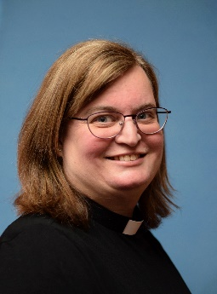
CASTLE METHODIST CHURCH

A letter from Rev Chris Preece:

October 2022

Dear Friends,

Over the past month much has happened. We have had a change of Prime Minister, Cabinet reshuffles and, of course, the death of the Queen. There has been a huge outpouring of affection for the Queen during this time and, from the conversations that I’ve had, many people watched her funeral. We really were, and are, part of history in the making.

Inevitably, at such a time, people look back to the connections that they maybe had with the Queen. Much has been shared during this time, including her sense of fun, her duty to serve others and her strong faith. Some of this can be brought together in the Jubilee tea party that the Queen had with Paddington bear. It brought a real smile to the nation when we finally learned that the Queen also kept a marmalade sandwich in her handbag for a time of emergency. This recording made and shared at the Jubilee has had such an impact that the two Paddington movies were shown around the time of the Queen’s funeral.

The Queen accepted others with love, grace and kindness, as does Paddington. We saw them both coming alongside one another, accepting hospitality from one another and being willing to have a smile along the way. God, revealed to us in Jesus, shows us in his life about hospitality and coming alongside others and accepting us for who we are. Yet through his death and resurrection we can experience the total acceptance of salvation through the love and grace shown by Christ which brings us new life.

We are called as disciples of Christ to reflect the love of God to everyone. This involves both giving and receiving from others. Learning to receive can be one of the most difficult things to do, yet we see Jesus receiving hospitality from others, as well as extending it himself. It may be that we can come alongside others, to share something of God’s love with them, maybe through a cup of tea or the like. In that encounter, maybe both people can give and receive something of God’s love within that time.

As we continue to reflect on the Queen’s life and all that she meant to so many, and as we remember her family in our prayers, let’s give thanks to God. Let us also think about how we can reach out to others so that they may see and encounter something of God’s love for themselves. We can maybe have a smile or two along the way as well!

God bless,
Chris

